ECONOMY GOD MODE — Detailed Engineering & Track Strategy
You have three people, a highly ambitious idea, and a project that could compete in finance, agentic payments, AI infrastructure, and technical innovation.
The important thing now is to understand exactly what each person is responsible for, what they need from the other two, and how you turn all three contributions into one compelling demo.
There's a critical deadline: Cal Hacks submissions close Sunday, October 25, 2026, at 9:00 AM Pacific. The official criteria explicitly reward functionality, creativity, technical complexity, intentionality, and real-world applicability.
Devpost
+1
So I would build the project as two layers:
Layer 1 — The spectacle: An interactive city where thousands of agents spend money, react to crises, and create economic consequences.
Layer 2 — The serious financial technology: A reproducible financial simulation engine where autonomous agents manage liquidity, issue loans, negotiate contracts, execute payments, and test interventions.
Layer 1 makes judges stop. Layer 2 makes them believe your engineering.

1. What you're actually building
Imagine the world begins with:

2,000
Simulated households

150
Businesses

5
Commercial banks

1
AI central bank
Proposed simulation scale, not a measured implementation result.
Every household has income, savings, debt, preferences, and living expenses. Every business has employees, customers, inventory, obligations, and bank accounts. Banks lend money and hold assets and liabilities.
Now introduce a crisis: one large bank loses 40% of a category of assets. Its solvency worsens, it restricts lending, and some businesses struggle to refinance.
An autonomous central-bank agent must propose a rescue strategy.
The central demonstration should show three different rescue strategies tested from the same starting state, making it possible to compare their costs and results.
This requires three systems.

2. Person 1 — Economic engine and financial correctness
Economic Systems Lead
This person is building the scientific backbone. It's the hardest role from an economics and correctness perspective.

Deliverable A: Financially consistent accounts
Every agent needs a financial balance sheet, not simply a floating-point money field.
For example, if a business pays a worker $200, the business loses $200 of deposits and the worker receives $200. The bank records the corresponding ownership change. If the business borrows $1,000, a matching liability and financial asset must be recorded.
Represent transactions as balanced journal entries. Use integer amounts in cents for the ledger.
A simplified transaction:
{
"transaction_id": "pay_1049",
"payer": "cafe_14",
"receiver": "worker_209",
"amount_cents": 20000,
"type": "salary",
"status": "settled"
}
The ledger posts debits and credits to the appropriate accounts and rejects duplicate transaction identifiers.
The system should pass invariants such as:

$\sum{}Debits=\sum{}Credits$
That means a hallucinating AI agent cannot create money by producing a convincing-looking JSON response. Money creation through bank credit or public-sector operations must be modeled explicitly.

Deliverable B: Economic behavior
Start with four basic activities:
Actor | Action | Economic consequence
Worker | Earn salary, buy goods, pay rent | Changes household deposits
Business | Sell goods, pay wages, buy inventory | Changes sales, profit, employment
Bank | Issue and collect loans | Changes credit, liquidity, and obligations
Government | Tax and distribute support | Changes household income and government balances
Economic behavior can use simple but defensible rules.
For example, a household could set a consumption budget using disposable income, savings, precautionary preferences, and debt obligations.
The specific rule should be documented and tested instead of hidden inside a model prompt.

Deliverable C: Crisis propagation
This is where the project gains technical depth.
If businesses cannot pay loans, banks experience losses. Depending on capital and liquidity constraints, they may refuse new credit. More businesses may then default.
Implement a simplified version of the Eisenberg–Noe clearing framework for obligations between banks, alongside explicit credit and liquidity rules.
This creates emergent contagion rather than preprogrammed bankruptcy animations.

Deliverable D: Fork Reality
The simulation should support:
Initial economy state: S₀

Economic shock
|
-------------------------
| | |
Universe A Universe B Universe C
No bailout Bank loans Direct cash
| | |
Results Results Results
Each branch should use a deep copy or isolated snapshot of financial state. For fair comparisons, keep the same initial conditions and random-number streams where possible, and repeat tests across multiple seeds.
Definition of done: A bank shock propagates through actual financial relationships, and three forks produce separately calculated outcomes while satisfying accounting tests.

3. Person 2 — Autonomous agents and agentic payments
Agent Intelligence Lead
This person makes the world intelligent, and should own the bulk of sponsor integrations.
The most important distinction: an AI agent proposes actions; the economic engine validates and executes them.
The agent should never directly update bank balances.

The agent workflow
Economic event
Business cannot meet payroll
Nemotron financial agent
Finds alternatives and proposes a loan
Policy and risk engine
Validates budget, credit, terms and permissions
Ledger settlement
Posts an authorized transaction atomically
Economy updates
Cash, debt and future obligations change
Build three important intelligent agents:
Business agent: Negotiates supplier prices, requests short-term credit, decides whether to continue operating, and reacts to reduced demand.
Bank agent: Reviews borrowing requests, assesses cash flow and collateral in the simulated environment, proposes terms, and protects its capital and liquidity positions.
Central-bank agent: Observes aggregate stress, generates intervention proposals, calls the simulation tool to test them, and compares outcomes.
The central-bank agent is your strongest NVIDIA × Nebius demonstration because it can reason across multiple tools and perform a genuine plan–test–revise workflow.

Agentic payment system
The most useful payment event would be an AI-run supplier negotiation.
A struggling café requests inventory from two suppliers. A supplier agent offers favorable payment terms. The café agent chooses an offer and asks to settle the initial payment.
The system checks authorization, records the contract, transfers money, and creates a future obligation.
For Coinbase x402, add an actual paid API service—for instance, an economic forecasting service offered to another agent. A successful protocol transaction should be verifiable separately from your internal simulation ledger.
For Fetch.ai, an important discovery from the official hackpack is that eligibility requires more than using a multi-agent framework. An agent must be registered on Agentverse, implement ACP, be accessible via ASI:One, and complete its primary workflow within that conversation.
fetch.ai
That means Person 2 should expose something like:
“Stress-test my bank against a credit shock and recommend an intervention.”
The Fetch.ai agent performs the workflow using your simulation backend and returns the results within ASI:One. The pretty frontend alone does not satisfy that sponsor requirement.
Definition of done: At least one agent independently evaluates financial alternatives, calls real tools, proposes a valid transaction, completes sandbox settlement, and produces an inspectable decision trace.

4. Person 3 — The visual economic universe and integration
Product & Experience Lead
This person has one objective: convert complex engineering into an experience a judge understands without prior economics knowledge.
The frontend should have four views, not dozens of unrelated features.
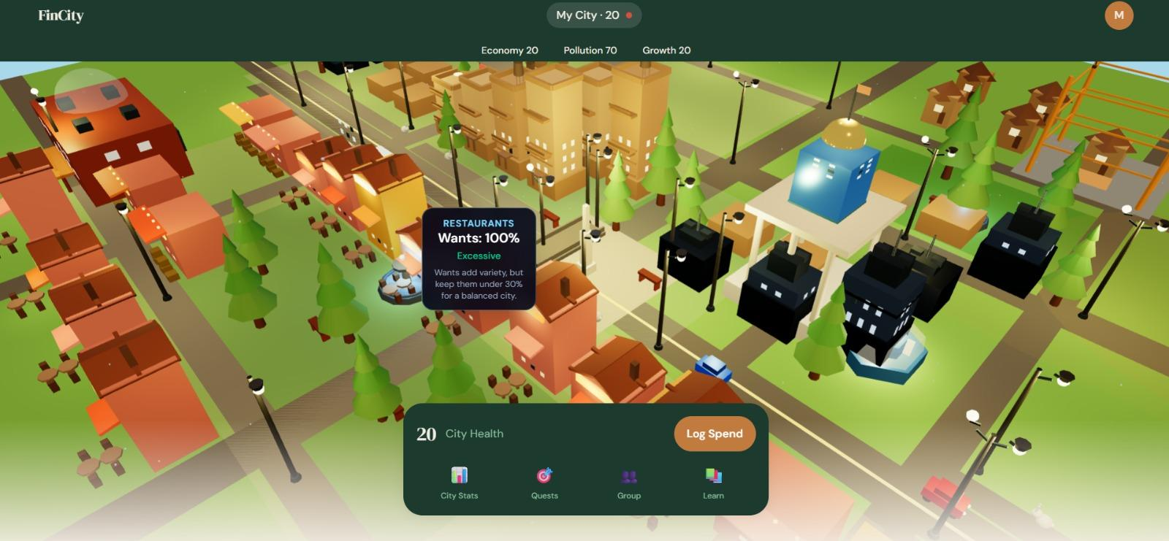
World View
An animated city with economic activity visible through buildings, businesses, jobs, bankruptcies, and payments. District colors indicate economic stress. Click any institution to inspect its finances.
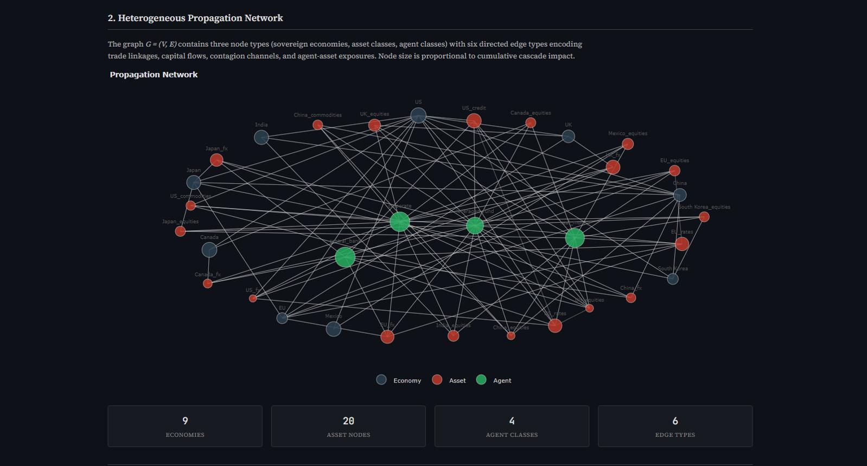
Financial Network View
Show banks, borrowers, financial exposures, payment flows, and default cascades. When one institution fails, connected counterparties respond according to the model.
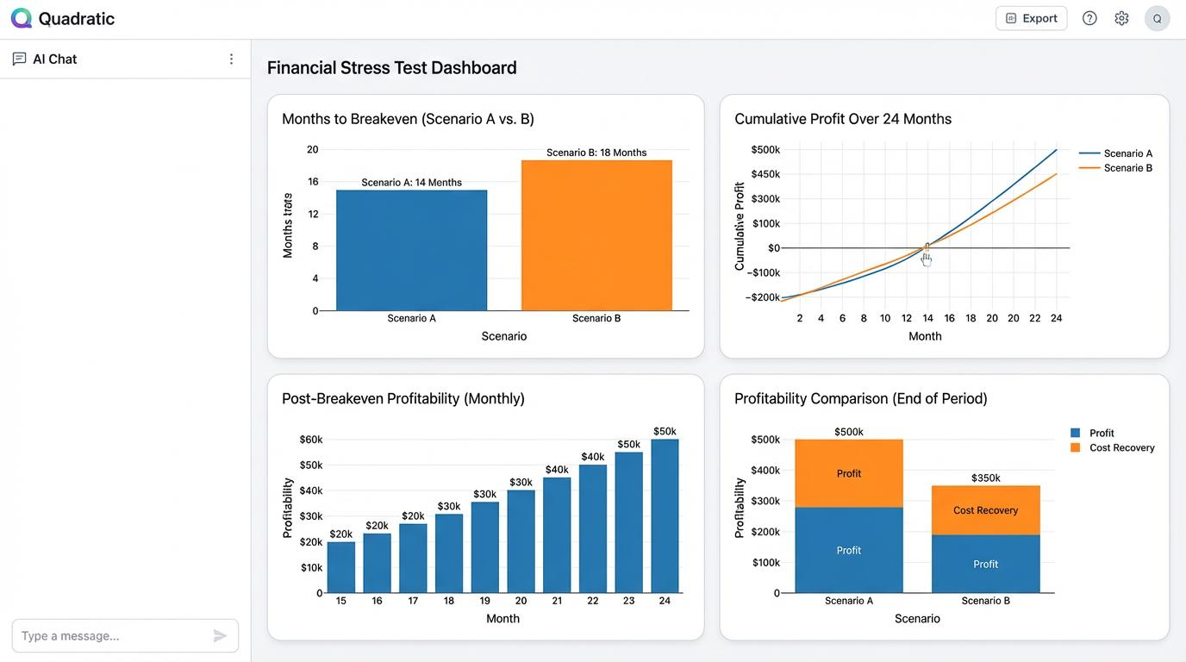
Fork Reality
Four universes side by side. Compare employment, insolvency, government spending, cash flow, and intervention performance.
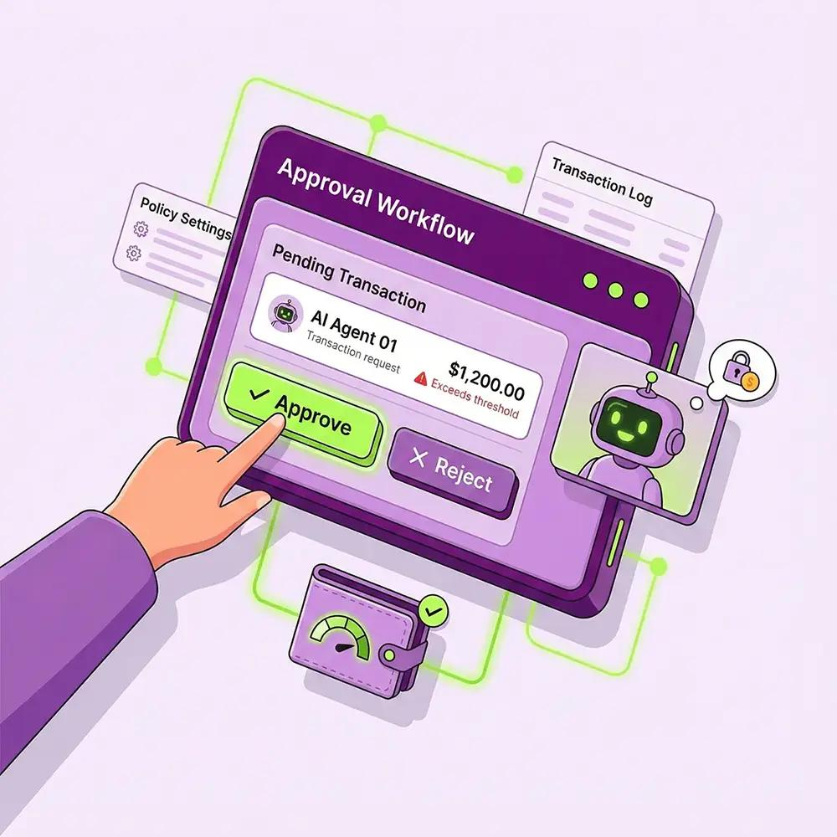
Agent Inspector
Select an economic agent and view its goals, observations, chosen actions, financial obligations, completed payments, and explanations.
The frontend should use one shared event format. For instance:
{
"event_type": "loan_default",
"simulation_id": "world_a",
"agent_id": "business_42",
"counterparty_id": "bank_2",
"amount_cents": 1250000,
"simulation_tick": 84
}
Person 3 subscribes to events, updates the visual state, and connects events to economic metrics. That preserves a clean separation between visual presentation and actual calculation.
Definition of done: A judge can create a world, trigger a shock, watch a resulting cascade, inspect an agentic payment, and compare multiple futures without using the terminal.

5. One end-to-end scenario that connects all three people
This is how the complete system should operate.

Demo: Save the Economy
Step 1 of 6 · Person 1

A healthy city is running
The financial engine processes wages, consumption, credit, taxes and business payments. Person 3 renders the economy in real time.
PreviousNext
Notice something important: nobody has built an isolated feature here. The same financial engine is responsible for every result, the same agent system reasons about decisions, and the same UI shows the entire experience.
That is the architecture you want judges to investigate.

6. Which finance tracks deserve the most engineering effort?
The current official Cal Hacks prize list confirms these categories, including Hyphenate, CRS, Capital One, Coinbase, Fetch.ai, and Visa.
Devpost
Here is the coverage strategy I would use.
Prize | Specific feature to present | Feasibility
Hyphenate Autonomous Finance | AI-run treasury, liquidity and lending workflows | Core focus
CRS Financial AI Agent | CRS-backed autonomous bank agent | Strong if API works
CRS Best Overall | Full financial agent lifecycle powered by CRS | Strong if integrated deeply
CRS Fraud / Identity | Fraudulent simulated financial activity and CRS-supported detection | Additional work
CRS Unexpected Use | Using CRS to power a living financial world | Plausible if meaningful
Coinbase x402 | Real agent-to-agent paid economic information service | Strong standalone demo
Fetch.ai | Registered financial simulation agent operating through ASI:One | Requires complete sponsor workflow
Capital One Nessie | Bank account and lending-related sandbox operations | Separate adapter required
Visa Shopping | Autonomous consumer agent compares, buys, and settles purchases | Requires strong shopping UX
The Visa category is your weakest natural match if the product remains a macroeconomic research simulator. You can support it by giving visitors their own autonomous consumer agent that shops within the economy, but do not promise eligibility without checking what Visa expects.

The non-finance prizes I'd target
Prize | Why
Most Technically Advanced | Financial correctness, default cascades, multi-agent optimization
Most Creative | Controllable economic universe with multiple futures
Figma Best Design | Highly interactive financial simulation interface
Microsoft Built for the Real World | Financial stress testing as a practical enterprise use
Creao Team Empowerment | Collaborative exploration and decision-making workflows
Armadin Security | Adversarial attack scenarios against autonomous payments
MLH Solana | Settlement of selected machine-to-machine transactions
MLH Tiger Data | High-throughput economic event history and time-series analysis
MLH Snowflake API | Macroeconomic datasets and model-grounding workflow
These last integrations are conditional. Some are substantially more work than the core project.
Priority order: Core economy → Nemotron financial agents → x402 → one meaningful banking integration → Fetch.ai ASI:One workflow → visual polish → further track-specific integrations.
I would specifically avoid implementing Solana, Snowflake, and additional payment platforms before the core demonstration is reliable.

7. Working schedule for the remaining hackathon
The official submission deadline is 9 AM Pacific on October 25. Since today is October 24, you need to divide the remainder into integration milestones, not broad daily goals.
First
Establish the end-to-end backbone
Person 1: A simulated world with real ledger transactions.
Person 2: One Nemotron agent that proposes a structured action.
Person 3: A working UI that receives actual events.
Next
Prove the core research idea
Implement one financial shock, show resulting bank and business effects, then run three branches from the same state.
Every branch result must come from calculation, not hard-coded frontend numbers.
Then
Complete payment and financial integrations
First x402, then your selected bank API, then Fetch.ai if there is sufficient time to satisfy its full workflow requirements.
Before 9 AM
Freeze and submit
Record the demo, run the same scenario repeatedly, prepare a short technical explanation, document sponsor integration evidence, and submit before the deadline.

8. The biggest mistakes to avoid
There are three especially dangerous ones.
Mistake 1: Pretending the LLM runs the whole economy. It shouldn't. An LLM is useful for planning, negotiation, and interpretation, but accounting, settlement, insolvency, and simulation constraints must be enforced by deterministic code.
Mistake 2: Making Fork Reality visually impressive but scientifically meaningless. If all three branches have artificially programmed success percentages, judges won't be impressed when they inspect the implementation. Even a small world with genuine outcomes is better.
Mistake 3: Treating every sponsor award as an API checklist. Fetch.ai's requirements alone include registration, ACP, ASI:One discovery, and a complete in-conversation workflow. That's a substantial integration, not a one-line SDK import.
fetch.ai

9. The three deliverables I would insist on
Person 1 — A verifiable financial world
A reproducible simulation with audited ledger transactions, actual economic interactions, crisis propagation, and branch comparisons.
Person 2 — A genuinely autonomous financial agent
An agent that observes financial state, proposes actions, uses tools, executes authorized payment workflows, detects failed actions, and retries safely.
Person 3 — A breathtaking but truthful live demo
An interactive city showing what changed, what caused it, which financial transactions occurred, and which AI-generated interventions performed best.
The most important design choice is to make the autonomous economic intervention the centerpiece.
The city is the interface. The ledger is the source of truth. The AI agents are the decision-makers. Agentic payments are the execution mechanism. Fork Reality is the experiment.
That combination makes Economy God Mode a coherent financial research system, rather than a collection of hackathon sponsor integrations.
And if you have to choose between another prize track and making that demonstration undeniably real, choose the demonstration.

